Common Troubleshooting

## 1 Smart Home Unresponsive

A: 1. Please use battery power and check whether it is sufficient.

2. Please check whether the wiring is correct.

Note: Before the control board leaves the factory, there is no program related to smart home. You need to upload corresponding programs to realize the function.

## 2 Computer Does Not Recognize USB Port

A: 1. Please make sure you have installed the development board driver referring as following:

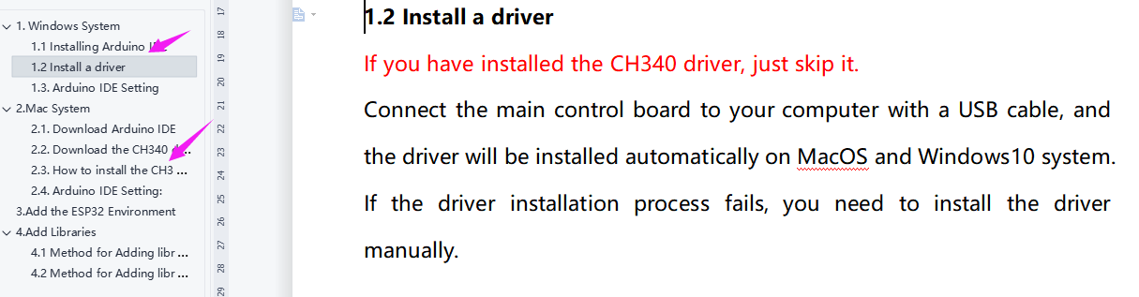

1. Please check whether USB cable is in good condition.

## 3 Program Compilation Error

A: Has the library file been added? For how to add, please refer to: **4.****Add Libraries**

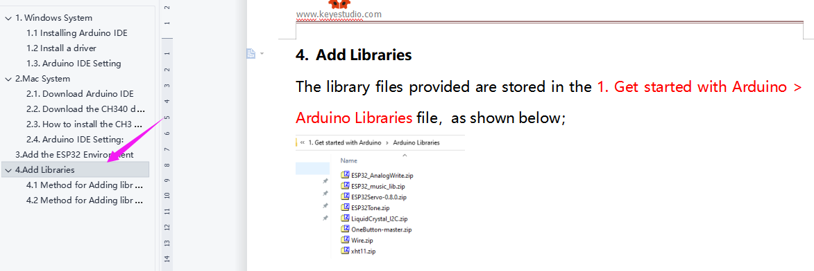

## 4 Program Fails to Upload

A: Please select the correct development board **ESP32 Dev Module** and port. You may check the port corresponding to the development board on the device manager of your computer. If you don't have this board on your Arduino IDE, please refer to: **3.Add the ESP32 Environment**

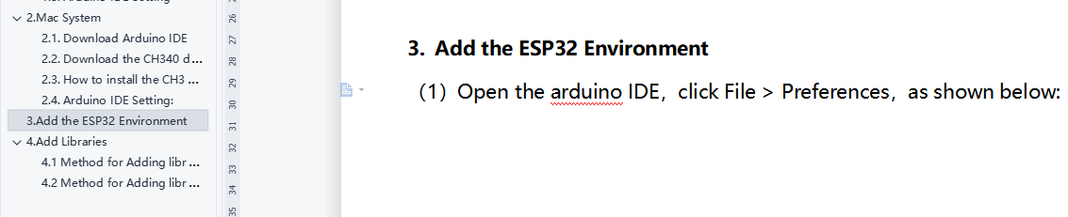

## 5 Servo Is Hot

A: 1. Do please reset the steering gear to 90 degrees before installing, avoiding servo being blocked and burnt when the it executes the routine program. For specific operations, please refer to **Step 7** in the installation steps.

2. When you install the window, the self-locking nut should not be tightened too much to ensure that the window can slide, avoiding the servo being blocked and hot to burnt when the program is executed.

## 6 APP Disabled or Unresponsive Connection to Bluetooth

A: APP does not respond when controlling smart home: make sure that the functional program controlled by APP has been uploaded. Separate courses for each sensor are provided in the course. So when you find that one sensor does not respond, you may refer to the course to have a check and test. For example, when using APP to control the smart home without response, please refer to **Project 13.1 Test APP** to test ESP32 to see if it receives data normally.